CO1 Assessment Tool 1

CSA1519-Cloud Computing and Big Data Analysis

Name: Kavya Jasmine V
Reg no:192521133
Course code:CSA1519

1)Cloud computing fundamentals

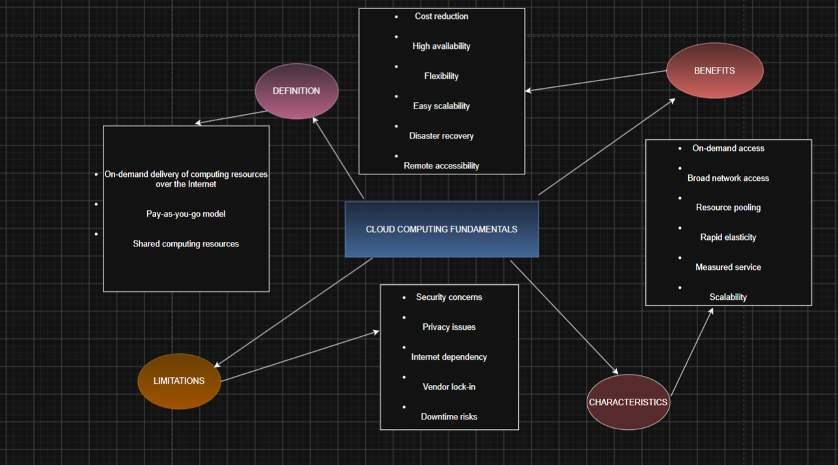

2)Evolution of cloud computing

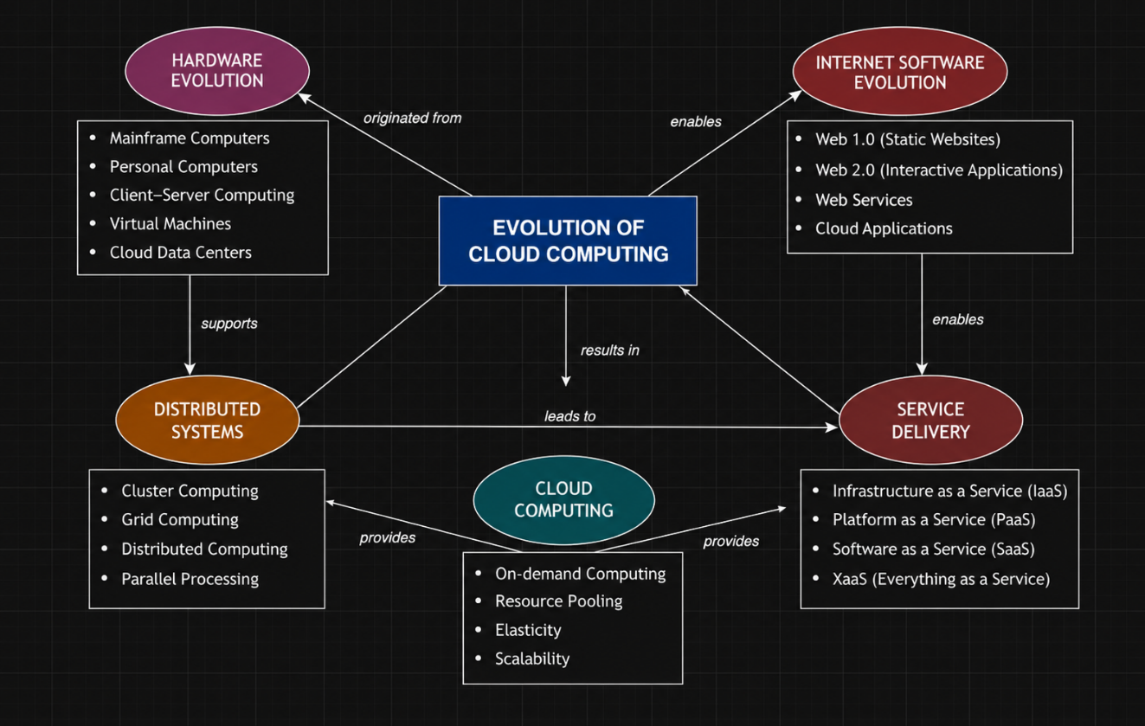

3)Cloud service models
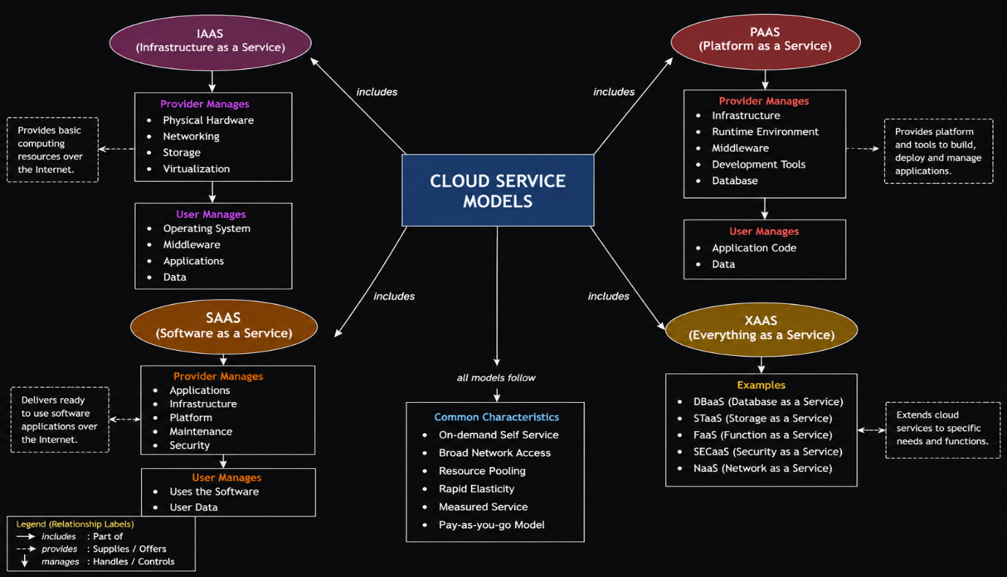

4)Virtualization and web services in cloud computing
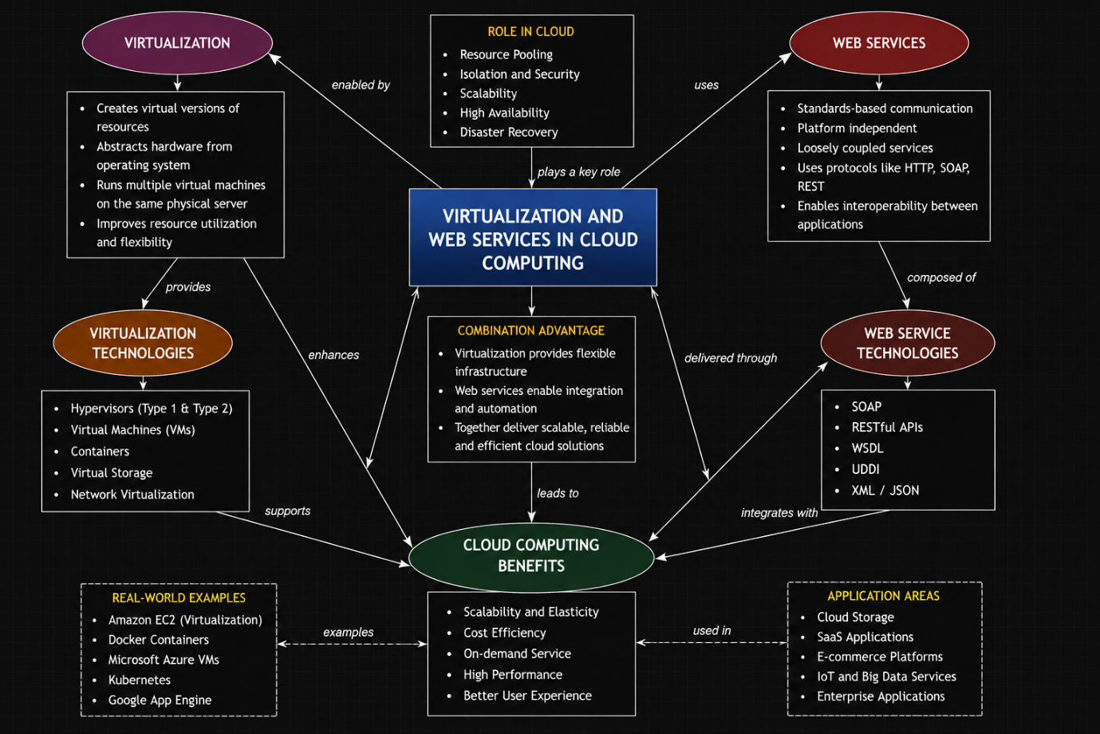

1. Evaluate the effectiveness of your concept map in representing cloud computing principles. Which design decisions most strongly support your solution, and why?
The concept map effectively represents the fundamental principles of cloud computing by organizing related concepts in a logical and structured manner. The use of branches for cloud characteristics, service models, virtualization, web services, and scalability makes the relationships between concepts easy to understand. The decision to place cloud computing at the center and connect all supporting technologies using labeled arrows improves clarity. This design helps explain how different cloud components work together to provide reliable, flexible, and scalable services.

2. Analyze how scalability, elasticity, and resource management influence the architecture shown in your concept map. What challenges could arise if these capabilities were absent?
Scalability allows the cloud system to handle increasing numbers of users by adding resources when needed. Elasticity automatically adjusts resources based on workload, ensuring efficient performance and reducing unnecessary costs. Resource management optimizes the allocation and monitoring of computing resources for better utilization. Without these capabilities, the system may experience slow performance, service interruptions, resource wastage, increased operational costs, and poor user experience during high traffic periods.

3. Justify the selection of the APIs, web services, or cloud services included in your concept map. How do they contribute to the overall functionality and efficiency of the system?
REST APIs and web services enable communication between different cloud applications and services. They support data exchange, system integration, and interoperability across platforms. Virtualization provides efficient resource utilization by allowing multiple virtual machines to run on the same physical hardware. Cloud services such as IaaS, PaaS, and SaaS provide flexible infrastructure, development platforms, and software solutions. Together, these technologies improve system performance, reliability, scalability, and cost efficiency.

4. Critically examine the relationships between the components in your concept map. How do these interactions improve reliability, performance, or user experience?
The components are interconnected to demonstrate how cloud computing functions as a complete system. Virtualization enables efficient resource allocation, while web services and APIs allow seamless communication between applications. Service models provide appropriate levels of cloud resources based on user requirements. Scalability and elasticity ensure consistent performance even during high workloads. These interactions improve system reliability, reduce downtime, enhance response time, and provide users with a smooth and efficient experience.

5. Reflect on the process of developing your concept map. How has creating and analyzing the map changed your understanding of cloud computing architecture, and what improvements would you make if you were redesigning it?
Creating the concept map improved my understanding of how cloud computing technologies are connected and how different service models, virtualization, and web services support modern cloud applications. It helped me visualize the relationships between cloud components rather than studying them individually. If I were redesigning the concept map, I would include more real-world examples, cloud deployment models (public, private, and hybrid), and additional security concepts to make the architecture more comprehensive and practical.

